Certificate of Achievement

This Acknowledges That
Your Name

Has Successfully Completed
2022 – England cycle
2,000  miles | 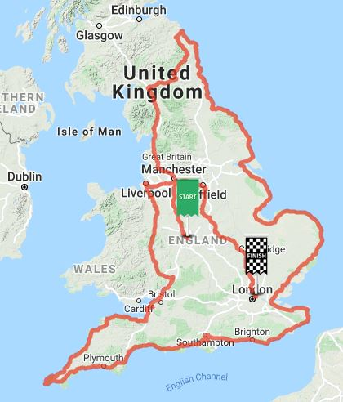 | 