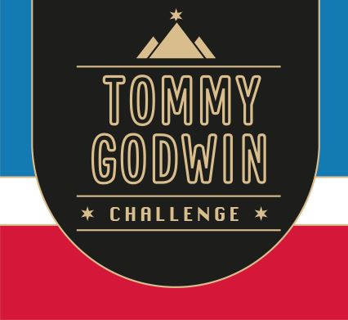

Certificate of Achievement

This Acknowledges That
Your Name

Has Successfully Completed
Event 1 - Lands End to John O’Groats 2021
912  miles | 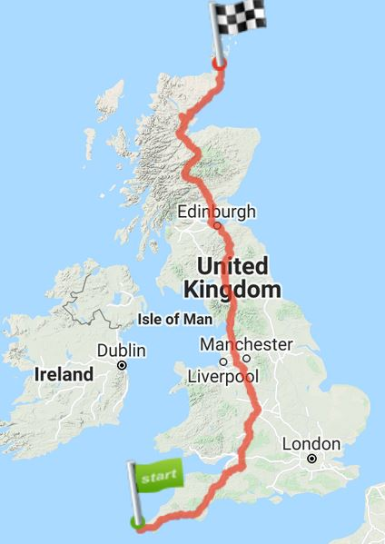 | 