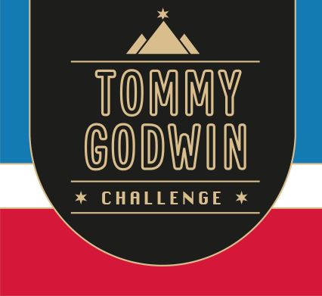

Certificate of Achievement

This Acknowledges That
Your Name

Has Successfully Completed
2022 – Northern Ireland Swim
100  kms | 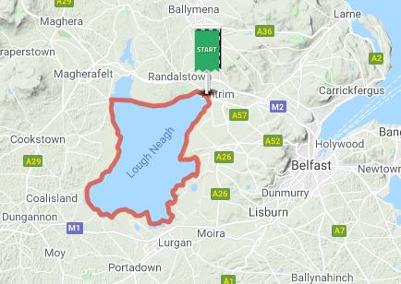 | 